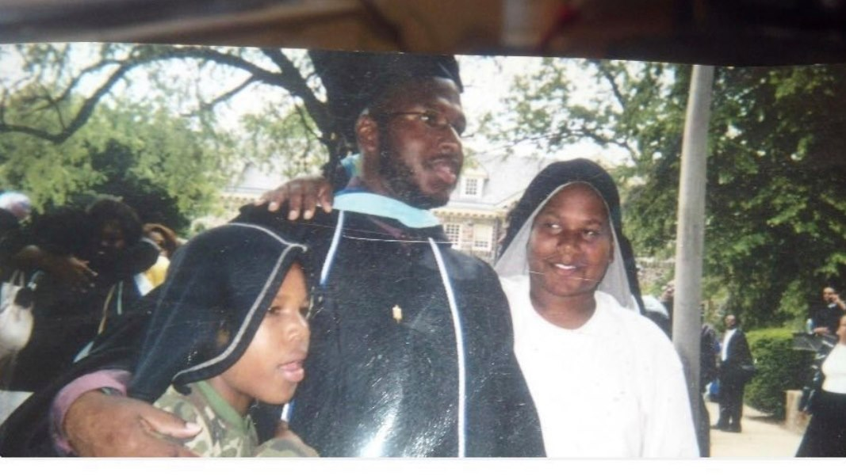

My name is Marc Reason. I have been an educator for 20 years. I grew up in North Philadelphia. Going into my 7th grade year, my mom moved us to Bristol Pa. and that is where I finished my pre college education. I didn't begin thinking about becoming a teacher but when it was introduced to me as a career change I quickly realized that it is my calling. My favorite thing about working with kids is their honesty. They teach me as many life lessons as I teach them their daily assignments. All children can achieve and succeed without barriers. It is our responsibility to push them to be intellectually curious and support, not hinder their growth. "They don't care how much you know until they know how much you care," is the quote I teach by. They are supposed to surpass our levels because each generation should. We just can't be intimidated by their brashness and intellect.

