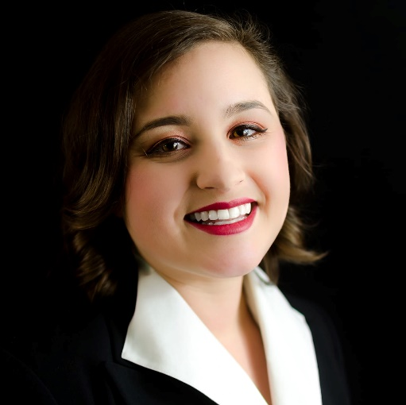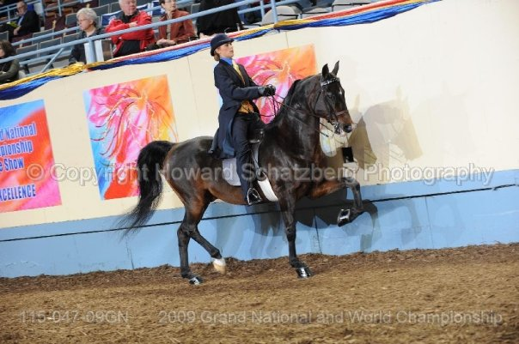

Did you always want to be a teacher, or did you dream of some other career?
When I was a Kindergarten student, I wanted to be a famous ballerina. I went to dance school upwards of four to five days per week and danced for hours. Eventually, when I was eleven years old, I transferred to a professional dance school to eventually dance with the world renown Pennsylvania Ballet Company. I ended up getting permanent damage to my Achilles tendon, so that career was over for me, but at the same time, I found my love for music. Eventually, I decided to be an opera singer, and attempted to take singing gigs. For college, I attended the Fox School of Business at Temple University for actuarial science after a lot of discouragement from family and teachers. I hated business school and loved what my choir friends were doing, which was teaching music! I left business school to attend the Boyer College of Music and Dance at Temple to start teaching music, and I fell in love with it. I still take opera gigs as well as teach, but teaching is my ultimate passion.

What is your favorite thing about working with kids?
My favorite part of working with kids is their minds. At a young age, children see the world through a very limited scope. It's rainbows and games, swimming underwater without swimmies, sharing their guitars and greeting everyone with excited "hellos". They aren't afraid to sing or move. They want to be silly and show their individual expressions. The decisions that are made are made without fear of failure. They remind me that the world isn't miserable around me, and encourage me to come to work with smiles and things to share as well. I wouldn't be as high energy or optimistic about my own life if the kids weren't there to model for me as I model for them.

What is one silver lining of COVID?
We've all gained a myriad of new skills from this pandemic. I consider myself to be wildly behind on the technological advances of the world. I have second grade students still teaching me how to do internet things! My own mother had to teach me how to use Zoom. I can confidently say after two months of online teaching that I could hold a master class on integrating technology meaningfully into every day learning. Based on interactions with my students and observing student to student interactions, I think that another silver lining is that the students have a brand new outlook on life at school. Many of them have expressed to me that they took our school community for granted. They are sitting and learning without the distractions of the world around them, which from a teaching perspective, is really nice. I feel like I can gather information from some students who never participate because they now have multiple avenues of participation.

If you had $1000 to spend on your class(es), what would you buy?
The young educator in me wants to buy a class set of tubano drums, but the realist in me wants recording equipment for my older students.

What is your hidden talent?
I used to show horses! (See photo!). I can walk, trot, cantor, and gallop on a horse. My very first horse was named Timmy. Other horses I used to ride were Chip, Diana, and Blue. I trained a horse named Scotch to respond to cues for showing even though I didn't own him. Out of all of my horses, Scotch is the one I miss most because we had a special bond. I still go up to a farm in Phoenixville called Sheeder Mill Farms to go trail riding on weekends!

